Freelance web development

### BILL TO PROJECT DETAILS Invoice No: #INV000014

Gulf organization for research

and development GSASgate maintenance **Invoice Date:** 01/03/24

QSTP, Tech 1, Level 2, Suite 203, P.O. Box: 210162, Doha - Qatar

January 2, 2024 – January 31, 2025

**Due Date:** 10/03/24

|  |  |  |  |
| --- | --- | --- | --- |
| **DESCRIPTION HOURS** | | **RATE** | **TOTAL** |
| GSAS | 25 Hours | 600 INR / Hour | 15000 |
| GSB | 44 Hours | 600 INR / Hour | 26400 |
| 1st Payment Academic Application | - | 600 INR / Hour | 17000 |
|  |  |  | 58400 INR |

## Thank you for your business!

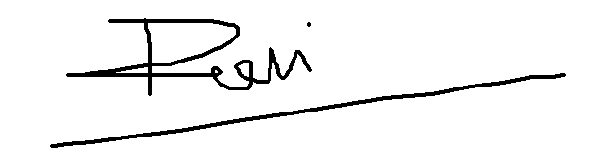

**Balance Due $ - 58400**  INR

### Terms & Instructions

Payment mode: Bank Transfer

**Account details:**

A/c No. : 200410110016436

Holder Name: Ravi Govindbhai Prajapati

Bank name: Bank Of India

IFSC code : BKID0002004

City: Ahmedabad

State: Gujarat

Country: India